

**PROGRAMMING FUNDAMENTAL LAB**

**SUBMITTED TO: SIR BILAL DAR**

**SUBMITTED BY: MAIRA EMAAN NASIR**

**REG NO: 2430-0153**

LAB TASK: 05

Question: 01

Write a program to print the numbers from 1 to 5 using a for loop.

CODE:

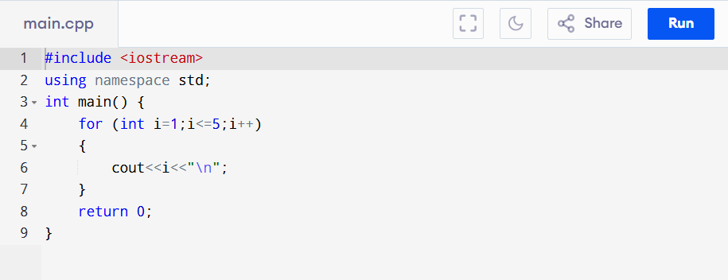

OUTPUT:

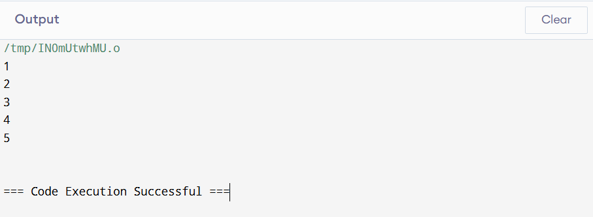

Question: 02

Write a program to find the sum of the first n numbers. The value of n should be provided by the user.

CODE:

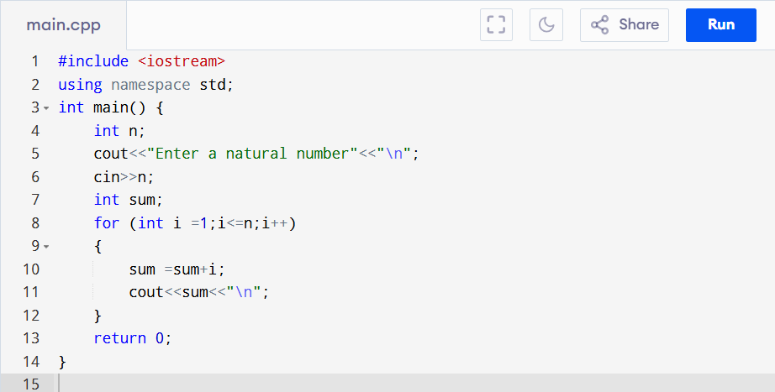

OUTPUT:

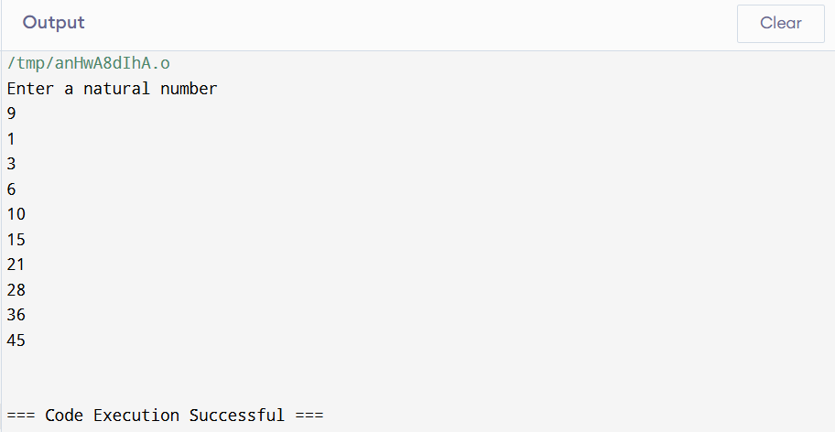

Question: 03

Write a program that takes a number …… user enter 5.

CODE:

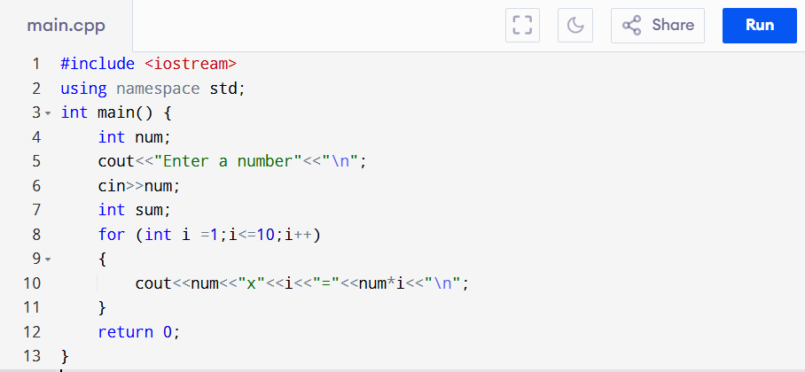

OUTPUT:

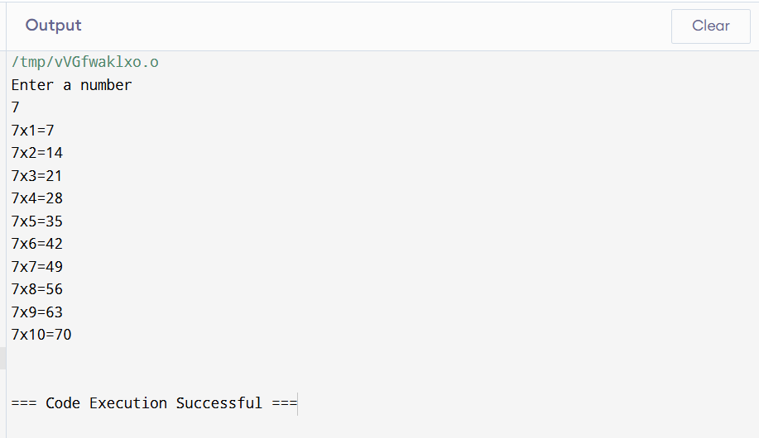

Question: 04

Write a program that prints…… using for loop.

CODE:

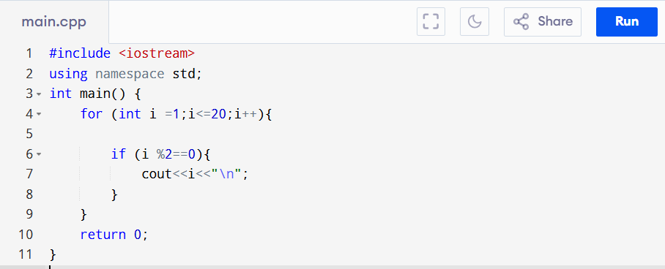

OUTPUT:

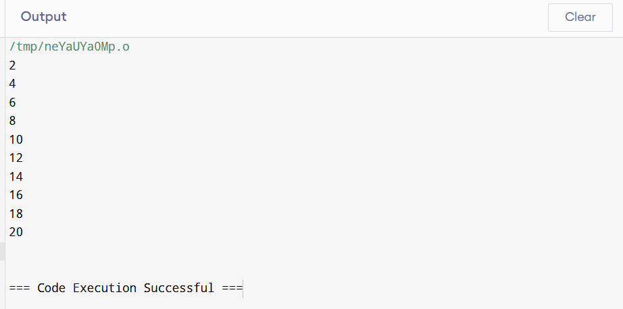

Question: 05

Write a program that prints the number…… 10 to 1.

CODE:

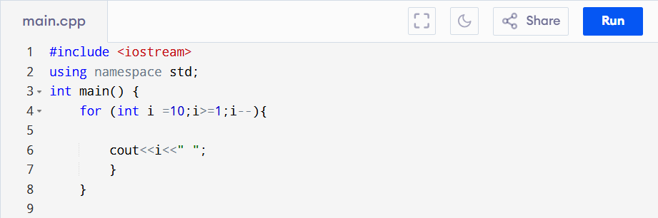

OUTPUT:

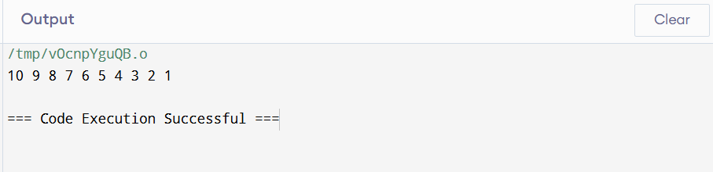

Question: 06

Write a program in C++ to display the cube of the number up to an integer.

CODE:

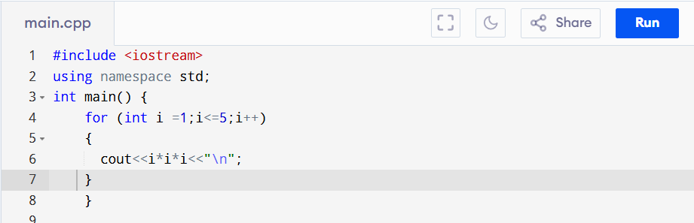

OUTPUT:

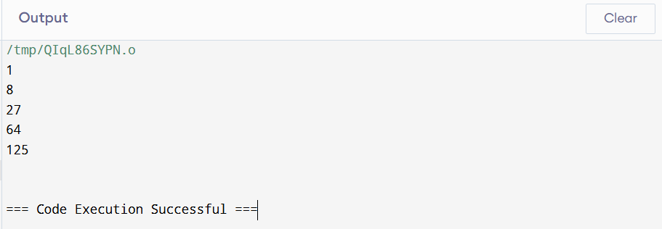

Question: 07

Display the corresponding grade for each student based on the entered marks. Display the appropriate grade.

CODE:

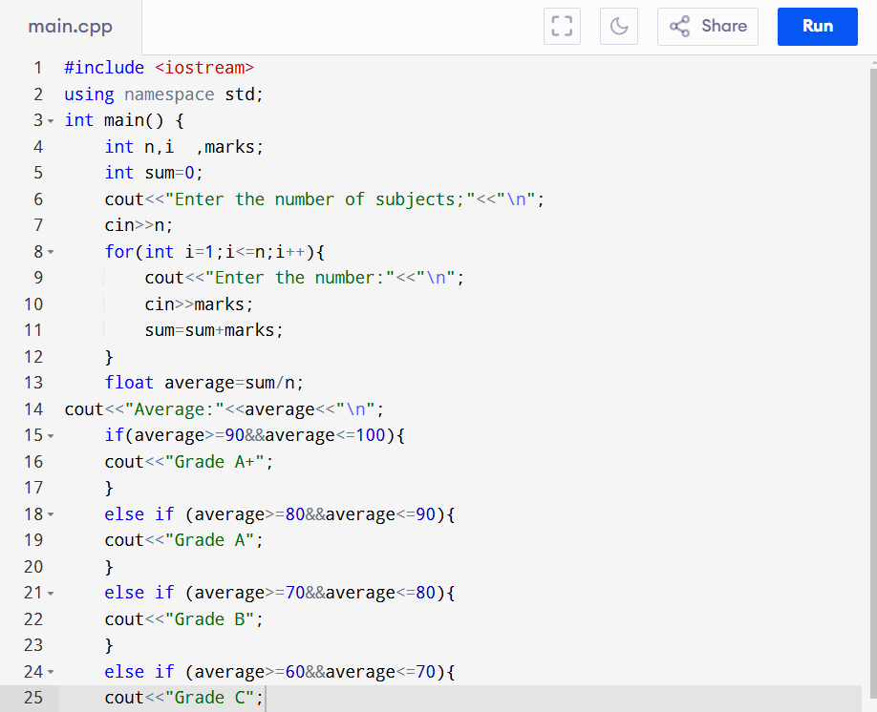

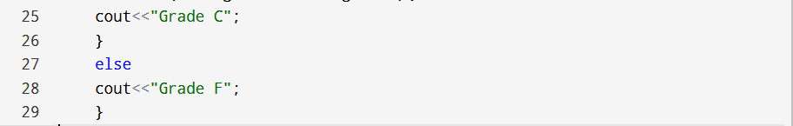

OUTPUT:

